A Predictive Agri-Business Intelligence System for Weather-Informed Farming Decisions using Power BI and Microsoft Azure.

Name: Michael Thomas Akolo

Student No:147595

Group: 4 C

An Information Systems Project Proposal Submitted to the School of Computing & Engineering Sciences in partial fulfilment of the requirements for the award of a Degree in Business Information Technology

Date Of Submission: November 2025

Declaration and Approval
I, Michael Thomas Akolo, declare that this work has not been previously submitted and approved for the award of a Bachelor’s degree by this or any other University. To the best of my knowledge and belief, the proposal contains no material previously published or written by another person except where due reference is made in the proposal itself.

Student’s signature:

………………………………….………….. [Signature]

……………26/11/2025…………………….………….. [Date]

Supervisor’s Name: _Benjamin Mundama

Abstract
Agriculture remains a cornerstone of Kenya’s economy, employing over 70% of the rural population and contributing significantly to the national GDP. However, climate change has introduced new layers of uncertainty in farming, particularly through unpredictable weather patterns that hinder the ability of small-scale farmers to make timely planting and harvesting decisions. Traditional reliance on seasonal trends has proven unreliable due to shifting rainfall cycles, increased drought frequency, and other extreme weather events. This uncertainty often leads to poor crop yields, food insecurity, and financial losses. The proposed project seeks to mitigate these risks by developing an Agri-Business Intelligence (Agri-BI) System that leverages the data processing and visualization capabilities of Power BI alongside the machine learning and AI services of Microsoft Azure. The system will collect and analyze real-time meteorological, satellite, and historical crop data to generate weather forecasts and actionable insights for farmers. Through intuitive, multi-layered dashboards and predictive analytics, the system will offer tailored recommendations on optimal planting and harvesting windows. An agile methodology will be implemented to ensure continuous feedback from users and stakeholders during system development, allowing iterative refinement. This project will ultimately empower smallholder farmers in Kenya with reliable data, improve climate resilience, and support sustainable agricultural productivity.

Keywords: algorithms, supervised learning, unsupervised learning, machine learning, Business Intelligence, predictive analytics, data processing, weather forecasts, agri-food sector, dashboard.

Table of Contents
Declaration and Approval ii
Abstract iii
List of Figures ix
List Of Tables x
List of Abbreviations xi
Chapter 1:Introduction 1
1.1 Background 1
1.2 Problem Statement 2
1.3 Aim 3
1.4 Specific Objectives 3
1.5 Justification 3
1.6 Scope and Limitations 3
1.6.1 Scope 3
1.6.2 Limitation 4
Chapter 2:Literature Review 5
2.1 Introduction 5
2.2 Current Agricultural Practices and Decision-Making in Kenya 5
2.3 Current Challenges Experienced Agricultural Planning Processes 6
2.3.1 Technical challenges that face Agricultural Forecasting Systems 6
2.4 A Review of Existing Predictive Agricultural Systems 6
2.4.1 Digital Green Advisory System 6
2.4.2 IBM PAIRS GEOSPATIAL Platform 7
2.4.3 aWhere Platform 8
2.5 Existing gaps in the Predictive Agricultural Systems 8
2.6 A Review of Possible Emerging Technologies 9
2.6.1 Microsoft Azure 9
2.6.2 Microsoft’s Power BI as an analytics tool 10
2.7 Proposed BI System 11
2.7.1 Justification for Proposed BI System 11
2.8 Conceptual Framework 12
Chapter 3:Systems Development Methodology 15
3.1 Introduction 15
3.2 Description of the Methodology Stages 15
3.2.1 Sprint 1: Requirement Gathering and Analysis 15
3.2.2 Sprint 2: System Design 15
3.2.3 Sprint 3: System Development 16
3.2.4 Sprint 4: System Testing and Validation 16
3.2.5 Sprint 5: Deployment and Maintenance 16
3.3 Deliverables 16
3.4 System Design Tools 17
Chapter 4:System Analysis and Design Description 19
4.1 Introduction 19
4.2 Requirements Gathering 19
4.3 System Requirements 19
4.3.1 Functional requirements 19
4.3.2 Non-functional requirements 20
Description 21
4.4 System Architecture 21
4.5 System Analysis 23
4.5.1 Use Case Diagram 23
4.6 System Designs 24
4.6.1 Class Diagram 24
4.6.2 Sequence Diagram 25
4.6.3 Database Schema 26
Chapter 5:System Implementation and Testing 27
5.1 Introduction 27
5.2 Implementation 27
5.2.1 Wireframes 27
5.2.2 Installation Procedures 28
5.2.3 System Manual 31
5.2.4 Access Levels and Login Credentials 32
5.2.5 Report Generation 35
5.3 Testing 38
5.3.1 Testing Environment 38
5.3.2 Test Cases 39
5.3.3 Test Results 40
Chapter 6: Conclusions, Recommendations, and FutureWorks 42
6.1 Conclusions 42
6.2 Recommendations 42
6.3 Suggestions for Future Work 43
6.4 Summary 43
References 44
APPENDIX A: TIME SCHEDULE 48
APPENDIX B: PLAGIARISM REPORT 49
49

List of Figures
Figure 1:A flowchart indicating Microsoft Azure's machine-learning structure 10
Figure 2: A power BI dashboard demonstrating its visualization abilities 11
Figure 3: A graphic demonstration of how Microsoft Azure and Power BI synchronize together to create a business intelligence system 12
Figure 4: The conceptual framework 14
Figure 5: A labelled diagram illustrating the architecture 22
Figure 6: Use Case Diagram 23
Figure 7: Class Diagram 24
Figure 8: Sequence Diagram 25
Figure 9: Database Schema 26
Figure 10: Wireframes 27
Figure 11: The ingestion of data into Azure SQL Database 28
Figure 12: Data pipelines to automate the data ingestion process. 28
Figure 13: Importing necessary libraries 29
Figure 14: Training the models and selecting the most appropriate one based on the MAE and R-squared metrics calculated. 30
Figure 15: Saving the predicted data as a CSV file 31
Figure 16: A Power BI dashboard containing visuals representing the predicted data. 31
Figure 17: A farmer inserting his/her credentials 33
Figure 18; A farmer logging in the app successfully 33
Figure 19: An administrator logging in to the app 34
Figure 20: An admin accessing the system 35
Figure 21: Code snippet for downloading the model summary performance report. 36
Figure 22: A front page view of the generated model summary performance report in a pdf format. 37

List Of Tables
Table 1: Deliverables obtained from each sprint in the Scrum methodology 17
Table 2: Tools used in the system development 17
Table 3: Functional Requirements 20
Table 4: Non-functional requirements 21
Table 5: A table describing the various models and their functionalities. 32
Table 6: A table detailing the access privileges along with the login credentials involved. 32
Table 7: A table describing the hardware specifications. 35
Table 8: A table describing the software specifications. 36
Table 9: A table highlighting the test cases done to verify the functioning of the system. 37
Table 10: A table detailing the outcomes of the test cases undertaken earlier on. 38

List of Abbreviations

AI-Artificial Intelligence
Agri-BI – Agri-Business Intelligence
API - Application Programming Interface
AWS – Amazon Web Services
BI – Business Intelligence
CIS - Climate Information Services
FAO - Food and Agriculture Organization
GIS - Geographic Information System
GRU - Gated Recurrent Unit
FRQ - Functional Requirement
NFR – Non-Functional Requirement
GDP – Gross Domestic Product
GIS - Geographic Information Systems
GUI – Graphical User Interface
IBM-International Business Machines Corporation
IT- Information Technology
IoT – Internet of Things
KMD - Kenya Meteorological Department
LSTM - Long Short-Term Memory
ML – Machine Learning
NCPB – National Cereals and Produce Board
NGO – Non-Governmental Organization
OOAD - Object-Oriented Analysis and Design
Py - Python
SMS – Short Messaging Service
SQL - Structured Query Language
TPU – Tensor Processing Unit
UML - Unified Modeling Language
USSD - Unstructured Supplementary Service Data
XGBoost – eXtreme Gradient Booster

Chapter 1: Introduction

Background
Kenya’s agri-food sector is a cornerstone of the country’s economy, employing more than 70% of the rural population and contributing significantly to the national GDP (Emongor, 2014). However, this sector is increasingly vulnerable to the effects of climate change, particularly erratic weather patterns that disrupt planting and harvesting cycles. These uncertainties pose a substantial risk to the productivity and income of smallholder farmers, who are the backbone of Kenya’s food supply. Within the broader field of agricultural commerce, accurate weather prediction and climate-resilient planning have become critical needs. In the era of digital transformation, business intelligence (BI) systems powered by tools such as Microsoft Azure and Power BI offer a promising path toward mitigating these uncertainties by enabling real-time weather monitoring and predictive analytics.
Climate variability has resulted in increasingly unpredictable rainfall, prolonged droughts, and abrupt weather changes that make agricultural planning difficult for farmers. Research shows that African agriculture is particularly climate-sensitive, with over 95% of farmed land dependent on rainfall (Kogo & Koech, 2021). The Food and Agriculture Organization (FAO, 2016) confirms that Kenya's agricultural output has suffered due to changing climatic conditions, causing a ripple effect on food security and economic stability. These disruptions are particularly hard-hitting for small-scale farmers, who often lack access to meteorological data or digital tools that could help them adapt. The absence of location-specific weather information means farmers continue to rely on traditional knowledge, which is increasingly unreliable under new climate realities.
Smallholder farmers, agricultural cooperatives, extension officers, and policymakers are among the most affected by weather uncertainty. Without timely and reliable forecasts, farmers risk planting at the wrong time, applying inputs inefficiently, or suffering losses from unexpected droughts or floods. The consequence of inaction is grave — crop failure, loss of livelihoods, rising food prices, and increased dependence on food aid (Kogo & Koech, 2021). Institutions also struggle to formulate evidence-based agricultural policies due to a lack of integrated, usable climate data. This creates a feedback loop where both decision-makers and grassroots actors are ill-equipped to respond to climate-induced shocks.
Several researchers and practitioners have recognized the need for digital solutions that integrate weather forecasting into farming practices. Projects such as Kenya’s CIS and Africa’s Digital Green initiative have sought to improve access to agri-weather data, though gaps remain in delivering user-friendly, predictive, and actionable insights (World Bank, 2020). Many existing systems lack real-time analytics or suffer from low adoption due to usability barriers. To bridge this gap, this project proposes an Agri-Business Intelligence (Agri-BI) system that uses Microsoft Azure’s machine learning capabilities and Power BI’s visualization strengths to generate location-specific weather forecasts and recommendations for smallholder farmers. By translating data into accessible, predictive dashboards, this system aims to enhance agricultural decision-making and build climate resilience across Kenya’s agri-food sector.

Problem Statement
Weather unpredictability caused by climate change is severely impacting Kenya’s smallholder farmers, who are responsible for a majority of the country’s food production. These farmers often lack access to reliable and timely weather forecasts, making it difficult to determine the best times to plant or harvest. As a result, crop failures, poor yields, and income losses have become more frequent (FAO, 2016). Research confirms that weather-related uncertainty is a growing threat to agricultural productivity in sub-Saharan Africa (Herrero & Notenbaert, 2010).
The core of the problem lies in the limited integration of digital tools in rural farming communities, where access to data-driven decision support is minimal. Inaccurate or unavailable weather data leads to inefficient farm management and resource use. Traditional weather stations are few and poorly maintained, while national forecasts are too generalized for localized decision-making (World Bank, 2020). Without predictive and region-specific data, farmers remain exposed to climate shocks that could have been mitigated.
This persistent gap not only threatens food security but also undermines efforts to modernize the agriculture sector. Without scalable and accessible solutions that address the data divide, smallholder farmers will continue to operate at a disadvantage, risking both livelihood and productivity. Addressing this problem requires a digital, data-centric approach to climate adaptation — one that leverages artificial intelligence and business intelligence to turn raw data into useful, predictive insights.

Aim
To develop a predictive Agri-Business Intelligence system using Microsoft Azure and Power BI to help small-scale farmers in Kenya manage weather-related uncertainties and make informed planting and harvesting decisions.

Specific Objectives
- To assess the current state of weather uncertainty in Kenya’s small-scale farming sector.
- To identify challenges faced by farmers in accessing and applying weather information for agricultural planning.
- To design a weather prediction model using Microsoft Azure AI services that forecasts localized agricultural weather conditions.
- To develop an integrated Power BI dashboard that visualizes predictive weather insights for use by smallholder farmers.
- To test and validate the accuracy and usability of the developed Agri-BI system with real-world data and user feedback.

Justification
This research is essential because weather unpredictability remains a critical barrier to agricultural resilience and food security in Kenya. By integrating AI-driven forecasting with visual analytics, the proposed Agri-BI system addresses both the data gap and the decision-making vacuum faced by smallholder farmers. Stakeholders such as government agencies, agricultural cooperatives, and NGOs can use the system to support evidence-based interventions and planning. Furthermore, by translating complex climate data into simple dashboards, the project empowers rural communities to adapt more effectively to climate change. This contributes not only to improved livelihoods but also to national policy goals on climate-smart agriculture and digital innovation.

Scope and Limitations

Scope
The proposed study focuses on developing a predictive Agri-Business Intelligence (Agri-BI) system that uses Microsoft Azure for AI-driven weather forecasting and Power BI for data visualization. The study will involve gathering weather data, designing predictive models, and building dashboards to inform planting and harvesting decisions. The system will target staple crops in selected regions of Kenya and primarily serve smallholder farmers. It will not address pest control, irrigation systems, or market price forecasting.

Limitation
Access to high-resolution weather data and internet connectivity in remote areas may hinder model training and real-time updates, and technical constraints in the development and deployment phases hence software bugs. To mitigate these issues, the project will use publicly available satellite and meteorological datasets, partner with local agricultural extension services for field-level support and feedback, and employ agile development methodologies to address technical constraints efficiently.

Chapter 2: Literature Review

Introduction
This chapter provides a comprehensive review of existing systems and studies related to the use of Business Intelligence (BI) and machine learning in agriculture, with a focus on time series forecasting for weather and market price prediction. The goal is to highlight the strengths and shortcomings of current solutions and establish a foundation for the proposed agri-business intelligence system. The review helps position this study within the broader context of agri-business intelligence solutions and aims to highlight how the proposed system will bridge knowledge and technological gaps through machine learning and business intelligence tools. The chapter concludes with a conceptual framework to illustrate how the system will operate.

Current Agricultural Practices and Decision-Making in Kenya
Agricultural planning in Kenya, particularly among smallholder farmers, is largely informed by traditional knowledge, experience, and seasonal trends. Farmers typically make decisions on crop selection, planting schedules, and harvesting times based on past climatic experiences, indigenous knowledge, or generalized advisories disseminated via radio or SMS (Waswa, 2006). Traditional farming decisions lack real-time data integration, often leading to poor timing in planting or harvesting. For instance, a delayed rainy season can cause entire crop failures if planting occurs prematurely (Mutua, 2021). Farmers often engage in manual planning processes without access to localized, real-time climate data (Alila, 2006). The KMD provides regional weather forecasts, but these are not sufficiently granular to support farm-level decision-making. As a result, farmers struggle to adapt to rapidly changing weather patterns brought about by climate change (Department, 2021).
Current weather forecasting processes include observational meteorology then announcements via local radio and TV stations; and extension services that operate manually or semi-digitally through SMS alerts. These systems are governed by policies from the Kenya Meteorological Department (Department, 2021) and county agricultural offices, but the reality is a gap in consistent, localized, and timely delivery of advisory. The expectation is real-time, hyper-local insights; the reality is generalized forecasts and lag in information dissemination. However, due to information asymmetry and limited access to decision-support tools, farmers remain vulnerable to climate-induced shocks (Rafael, 2023).

Current Challenges Experienced Agricultural Planning Processes
One major challenge is the unpredictability of rainfall patterns, which leads to poor timing of planting and harvesting activities (Kanda, 2022). Additionally, the lack of user-friendly tools to interpret meteorological data means that many farmers cannot act on available advisories. Infrastructure challenges such as limited internet penetration, low smartphone ownership, and poor digital literacy hinder the uptake of digital solutions. Furthermore, institutional fragmentation between meteorological services, extension agents, and farmers reduces the effectiveness of knowledge transfer (Autio, 2021).
Expectations from agricultural planning include timely, location-specific, and actionable insights. However, the current reality is marked by generalized forecasts, delayed advisories, and fragmented communication channels. This disconnect contributes to suboptimal crop performance and increased exposure to climate risks (Kogo, Environment, Development and Sustainability , 2021).

Technical challenges that face Agricultural Forecasting Systems
Climate unpredictability causes erratic rainfall, increasing crop failure risks. Traditional forecasting methods are not granular enough, lacking precision and spatial accuracy for localized predictions (Adede A. M., 2022). This significantly affects agricultural decision-making. Various predictive systems have been introduced to mitigate this problem. However, issues such as low forecast accuracy, poor mobile accessibility, and the inability to adapt models to evolving climate conditions limit their usability (Ndungu, 2021). Intervention attempts include agricultural weather SMS alerts and regional climate outlook forums but these often target large-scale agribusinesses or governmental actors, not smallholder farmers (ICPAC., 2021). A gap persists in interactive, intelligent platforms that integrate AI, real-time weather, and user-centric dashboards.

A Review of Existing Predictive Agricultural Systems
Various automated systems have been developed globally to support climate-responsive agricultural decision-making. These include AI-powered forecasting platforms, IoT-based farm monitoring systems, and GIS-integrated agricultural advisory services. They include:

Digital Green Advisory System
Digital Green is an IT-based platform that delivers agricultural advisories to smallholder farmers using video content tailored to local dialects and practices. Moreover, it is government-supported and spans over 4 countries, namely Kenya, India, Ethiopia, and Nigeria. Digital Green’s FarmStack provides tailored advisories by integrating sensor data with farmer profiles. Similarly to the proposed system, it employs various supervised machine learning algorithms such as Support Vector Machines (SVMs) and linear regression while the proposed system utilizes time-series forecasting. The system architecture includes a mobile interface for field agents, cloud storage, and AI modules for insight generation. In Ethiopia and India, it improved yield by 15% but struggled with model retraining and personalization. While it emphasizes privacy and user consent, its latency in data visualization reduces effectiveness during emergencies (Gandhi, 2007).
On the downside, even though Digital Green’s systems provide market information and farming tips via digital tools; these platforms have proven effective in increasing awareness and digital inclusion but are based on rule-based decision-making with limited predictive capabilities (Dayıoğlu, 2021). Their models are neither dynamic nor context-aware, and they do not factor in real-time weather conditions or market fluctuations. Moreover, their static content often leads to outdated recommendations, especially during volatile agricultural seasons (Aker, 2011).

IBM PAIRS GEOSPATIAL Platform
IBM PAIRS leverages AI, satellite, and weather data to deliver predictive analytics in agriculture. In contrast to the proposed system, it applies unsupervised machine learning algorithms such as Random Forest and Gradient Boosted Trees to predict drought risks and optimal planting dates. It was deployed in Brazil and the U.S. corn belt (Albrecht, 2020). Users aimed to reduce fertilizer overuse and maximize irrigation timing. Its architecture includes cloud-hosted geospatial databases, REST APIs, and web dashboards. In terms of performance, it registered 89% accuracy in field tests (Lu, 2021). However, some challenges included limited real-time adaptability in African rural setups. Its modular architecture made it scalable but not mobile-friendly for farmers (Albrecht, 2020).
However, IBM’s PAIRS Geospatial requires enterprise-grade infrastructure and that may be out of reach to the average local farmer; moreover, despite its advanced capabilities, the Pairs Geospatial platform requires extensive infrastructure and consistent internet connectivity, which renders it inaccessible to many rural communities in Kenya. In contrast, the proposed system leverages Power BI’s mobile capabilities, providing offline access to forecasts and dashboards—a critical feature in low-connectivity rural areas.

aWhere Platform
aWhere combines agronomic data with weather information to deliver actionable insights for farmers, agribusinesses, and NGOs. aWhere processes weather data from over 2 million points globally to deliver location-specific advisories (Ekine-Dzivenu, 2022). The models its systems utilize are similar to the proposed system, in that both are supervised; and require training and test data; thus, the k-nearest Neighbors and logistic regression machine learning algorithms. It is prominently used in West Africa and South Asia; it targets NGOs and governments. Its performance metrics are quite good as the accuracy levels hover at 85%, but its dependence on high connectivity limits usability in remote Kenyan regions (Alreshidi, 2019).
In short, aWhere utilizes precision weather modelling combined with historical data to provide high-resolution forecasts (Alreshidi, 2019). However, this service is primarily designed for large agribusiness clients and remains cost-prohibitive for smallholder farmers (Collins, 2018). Hence, the proposed system aims to render the same agri-predictive services to the average local smallholder farmers who can’t afford to access the premium platform.

Existing gaps in the Predictive Agricultural Systems
A common limitation among current agri-tech systems is their reliance on static data and non-adaptive models. Most platforms lack real-time data integration and do not support continuous model updates. For example, AgMarknet in India provides historical pricing but does not forecast future trends or adjust predictions based on weather conditions. This static approach undermines farmers’ ability to respond to sudden shifts in demand or climatic stress (Adede A. O., 2022)
Additionally, most systems do not feature modular, scalable architecture. FAO and KMD services are centralized and lack interoperability with market databases or farmer records. This reduces their capacity to provide holistic advisories that consider both climate and economic factors (Chibuye, 2023). In contrast, the proposed system will adopt a microservices-based architecture hosted on Azure, allowing decentralized data processing, real-time synchronization, and offline support via Power BI.
The accessibility issue is also profound. Services like aWhere and IBM Geospatial target large farms or corporations with ample resources, leaving smallholder farmers underserved. The proposed system addresses this gap by prioritizing mobile-first design and lightweight data visualization tools that function even under limited connectivity. Furthermore, the integration of supervised machine learning enables the generation of forecasts based on minimal data input, a crucial feature in areas with poor data availability.

A Review of Possible Emerging Technologies
As the saying goes, “Technology is ever-evolving,” and as such, here are emerging technologies that provide promising avenues for addressing the identified gaps. These technologies, when integrated effectively, offer a powerful platform for creating a responsive, localized agri-business intelligence system. Among the most notable are:

Microsoft Azure
Microsoft Azure provides a scalable ecosystem with services like Azure ML, Cognitive Services, and Blob Storage. Its AutoML feature simplifies model deployment. Azure supports multiple statistics programming languages such as Python and R; and machine learning frameworks such as TensorFlow and PyTorch thus offering modularity (Barga, 2015).
Other alternatives include Google Cloud AI and AWS Sagemaker are similar, but what makes Azure unique is that it offers better integration with Power BI (Microsoft, 2022). Sagemaker excels in raw performance while Google Cloud AI boasts TPU acceleration. However, Azure's intuitive interface and seamless data engineering pipeline building make it ideal for lean teams.

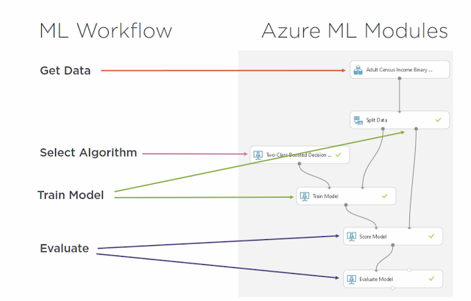
Figure 1:A flowchart indicating Microsoft Azure's machine-learning structure

Microsoft’s Power BI as an analytics tool
Allows interactive, low-bandwidth visualizations suited for farmers with smartphones. Unlike other visualization tools such as Tableau or Google Studio Looker, Power BI's offline capability and integration with Azure datasets make it optimal. Moreover, it facilitates the creation of interactive, intuitive dashboards that translate complex data into simple visual reports, enabling semi-literate farmers and policymakers to make informed decisions (Becker, 2019).
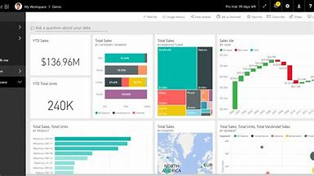
Figure 2: A power BI dashboard demonstrating its visualization abilities

Proposed BI System
The proposed system is a predictive agri-business intelligence solution designed to assist smallholder farmers in Kenya in making informed, climate-resilient decisions. It will leverage Microsoft Azure’s AI and machine learning capabilities to analyze historical and real-time weather data, and Power BI to visualize insights in a user-friendly manner. This system aims to bridge the gap between data producers (e.g., meteorological departments) and data users (farmers) by delivering personalized, actionable insights that are both timely and comprehensible.

Justification for Proposed BI System
The proposed solution will use Azure AutoML for model selection, beginning with a machine learning classifier algorithm, XGBoost, for its speed and high predictive accuracy in time-series forecasting (Chen, 2016). It handles missing data well and supports feature importance ranking. Risks include model overfitting, latency in retraining, and access issues in offline areas. Mitigation involves embedding lightweight ML models on edge devices and using periodic offline syncing. Trade-offs involve sacrificing real-time data ingestion for semi-batched updates to save bandwidth. The selection of Azure and Power BI is motivated by their interoperability, scalability, and cost-effective pricing tiers for NGOs or small projects.
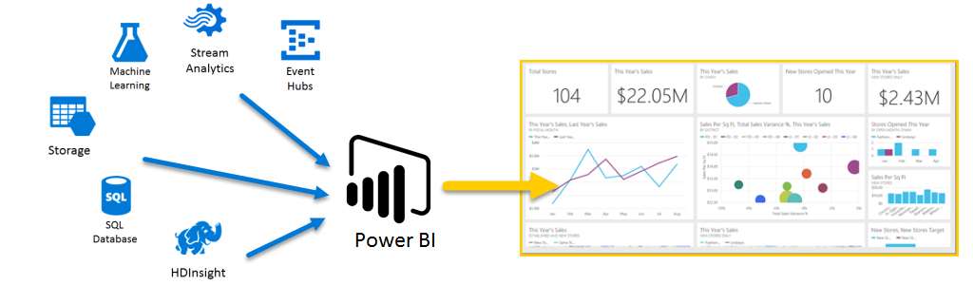
Figure 3: A graphic demonstration of how Microsoft Azure and Power BI synchronize together to create a business intelligence system
The system will provide functionalities such as:
- Localized Weather Forecasting: Using ML models trained on regional data to offer farm-level weather predictions.
- Crop Advisory Dashboard: Power BI dashboards showing optimal planting periods, rainfall predictions, and risk alerts.
- Mobile Integration: Interfaces optimized for rural use, with SMS, USSD, and offline sync capabilities.

Conceptual Framework
The conceptual framework illustrates how the proposed predictive agri-business intelligence system will function to support climate-resilient agricultural decision-making. The system is designed with a modular and data-centric architecture, ensuring continuous learning, ease of access, and stakeholder collaboration.
Once the farmer accesses the system through the Power BI mobile application, they can view tailored weather forecasts, planting recommendations, and crop advisory dashboards. The data behind these dashboards is generated from AI-powered weather prediction models hosted on Microsoft Azure, which process both real-time and historical weather data collected from multiple sources, including meteorological satellites, weather stations, and remote sensing platforms. The system begins by ingesting climatic and agronomic inputs, including real-time meteorological feeds, past weather patterns, crop calendars, and soil data. These inputs are then processed through machine learning algorithms that predict local weather outcomes like rainfall onset, drought risk, and ideal planting windows. The results are stored on Azure cloud databases, allowing for scalability and secure data management.

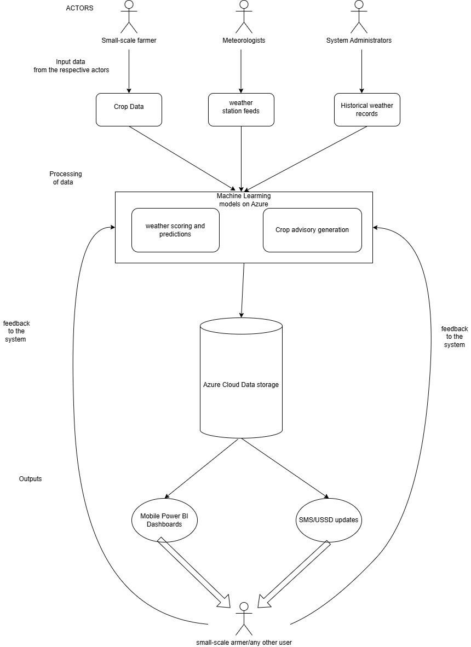
Figure 4: The conceptual framework

Chapter 3: Systems Development Methodology

Introduction
This chapter outlines the methodology adopted in the design and development of the Predictive Agri-Business Intelligence System. The selected methodology ensures that every stage of system development — from requirements gathering to deployment — follows a structured, iterative, and collaborative process. The Scrum Agile Framework was adopted for this project. Scrum was chosen due to its emphasis on iterative development, stakeholder collaboration, and flexibility in responding to changing requirements. It divides the project into short, manageable development cycles called sprints, typically lasting two to four weeks. Each sprint results in a potentially deliverable product increment that can be tested and reviewed by end users (Srivastava, 2017, May). This framework was particularly suitable because the system integrates multiple components — data collection, predictive modeling, and visualization — that benefit from continuous refinement and validation using real agricultural data.

Description of the Methodology Stages

Sprint 1: Requirement Gathering and Analysis
During this sprint, functional and non-functional requirements were gathered through interviews and questionnaires targeting farmers and other industry stakeholders, including agricultural officers. This was highly essential in ensuring the final product satisfies the pain points and gaps identified in the interviews. The activities undertaken during this sprint include identifying user roles such as Farmer and Admin; documenting system objectives and constraints; and developing user stories and acceptance criteria.

Sprint 2: System Design
This sprint focused on converting the requirements into detailed system models and architectural designs. Both structural and behavioral diagrams were created to illustrate system functionality and data flows. The activities carried out in the sprint are as follows:
- Designing UML diagrams, such as the use case and sequence diagrams.
- Creating the database schema
- Designing dashboard layouts and predictive model flowcharts.
- Holding sprint review sessions with my project supervisor to confirm design accuracy.

Sprint 3: System Development
The actual coding and configuration of system components occurred at this stage. Power BI and Microsoft Azure were integrated to enable data collection, analysis, and visualization. The activities undertaken in this sprint include:
- Coding and integration of backend logic in Python.
- Configuring Azure ML for predictive analytics.
- Developing Power BI dashboards for farmers.
- Holding weekly scrum meetings with my project supervisor to track progress and address any challenges encountered.

Sprint 4: System Testing and Validation
This sprint focused on validating the accuracy, usability, and performance of the system. The testing was done to ensure that each module met its acceptance criteria. The activities undertaken in this sprint include:
- Performing unit, integration, and system tests.
- Validating predictive model outputs against real market data.
- Holding sprint retrospectives with my project supervisor to identify improvement areas.

Sprint 5: Deployment and Maintenance
The final sprint involved deploying the system to the Azure Cloud and the Power BI service. Continuous maintenance was planned to incorporate real-time user feedback and update predictive models as new data becomes available. Hence, the activities undertaken in this sprint include:
- Deploying the system on Microsoft Azure.
- Monitoring system performance and updating ML models periodically.

Deliverables
Table 1: Deliverables obtained from each sprint in the Scrum methodology
Sprint | Deliverable
Sprint 1 | Requirements specification sheet
Sprint 2 | System Design Document and UML Diagrams.
Sprint 3 | A functional system prototype.
Sprint 4 | A tested and validated system.
Sprint 5 | A fully deployed and maintained system

System Design Tools
Table 2: Tools used in the System Development
Tool | Purpose
Lucid chart | Designing UML diagrams such as use case, class, and sequence diagrams.
Microsoft Power BI | Visualizing predictive analytics dashboards.
Microsoft Azure ML Studio | Developing and deploying machine learning models.
VS Code | The IDE used in implementing data preprocessing and model training Python scripts.
Python | Programming language employed to handle the backend Machine Learning logic.
Azure SQL Database | Managing weather datasets.
GitHub | Version control and collaborative development.
Figma
  Designing user interface prototypes and dashboard layouts.

Chapter 4: System Analysis and Design Description

Introduction
This chapter describes the analysis and design of the predictive agri-business intelligence system. The system leverages machine learning and data analytics to forecast three key weather parameters—maximum temperature, minimum temperature, and rainfall—across various towns in Kenya. It integrates predictive insights with Power BI dashboards to help farmers and agricultural stakeholders make data-driven decisions about planting, irrigation, and harvesting.

Requirements Gathering
The requirements were collected through literature reviews, observation of weather-dependent farming challenges, and consultations with agricultural experts and some small-scale farmers. The goal was to identify essential functionalities, such as weather data collection, predictive modeling, visualization, and report generation for the BI system. Moreover, the interview with the small-scale farmers provided a fresh perspective, as the farmers listed their pain points regarding weather-misprediction farming challenges; thus, this assisted in finalizing the user needs and system requirements.

System Requirements
System requirements can be simply described as the specifications a system or device must have, either hardware or software, that can satisfy the stakeholders’ interests involved (Lowe, 2003). System requirements encompassed the features and functionalities of the Ukulima Usoni BI system, both functional and non-functional requirements as shown respectively in sections 4.3.1 and 4.3.2 below.

Functional requirements
These are the specific features and capabilities that the end users require for the system to deliver the basic facilities that it should offer (Malan, 2001). for the agri-business intelligence system, they define the core functions the system must perform — including data input, processing, prediction, and output visualization. These requirements are observable in the final system as interactive dashboards, predictive models, and data-driven insights. The system’s functional requirements, which relate to its core weather forecasting and decision-support functionalities, are listed in the table below.
Table 3: Functional Requirements
ID | Description
FRQ 1
  The system should provide a simple and intuitive user interface that allows easy navigation between dashboards.
FRQ 2 | The system should allow administrators to upload and update historical weather data to the Azure SQL database.
FRQ 3 | The system should process and clean the input data to handle missing values and outliers before model training.
FRQ 4 | The system should enable analysts to train multiple machine learning models (Linear Regression, Random Forest, and KNN) to predict weather patterns.
FRQ 5 | The system should allow users to view forecasted data for maximum temperature, minimum temperature, and rainfall across various towns.
FRQ 6 | The system should automatically store prediction outputs in the forecast results database table.
FRQ 7
  The system should integrate with Power BI to visualize both historical and predicted data trends in interactive dashboards.
FRQ 8 | The system should generate downloadable reports summarizing forecast results and model performance metrics.
FRQ 9 | The system should allow the administrator to manage users, including adding, editing, and revoking access credentials.
FRQ 10 | The system should provide an interactive dashboard — that allows users to manipulate the visuals displayed on the dashboard.

Non-functional requirements
They define the quality attributes and operational standards that the system must meet. Moreover, they specify how well the system performs its functions rather than what functions it performs (Chung, 2012).These include usability, performance, scalability, security, and availability standards that ensure a reliable and user-friendly experience. The non-functional requirements of the agri-business intelligence system are outlined in the table below.
Table 4: Non-functional requirements
ID | Description
  NFR 1
  The system should provide a simple and intuitive user interface that allows easy navigation between the dashboard and the system components.
NFR 2 | The system should ensure high availability through Microsoft Azure hosting, allowing access at any time.
NFR 3 | The system should implement secure authentication and authorization to restrict access to registered users only.
NFR 4
  The system should process and return predictions efficiently within a reasonable response time.
NFR 5 | The system should maintain data integrity by ensuring accurate storage and retrieval of weather records and forecast results.
NFR 6
  The system should support scalability to accommodate additional towns and expanded datasets in future updates.
NFR 7
  The system should provide real-time synchronization between Azure SQL Database and Power BI dashboards.

System Architecture
A system architecture is the conceptual framework that defines the structure, behavior, and functional interactions within a system. It serves as a blueprint that outlines how various system components communicate to achieve the overall objectives of the application (Klein, 2013, June). The architecture of the Predictive Agri-Business Intelligence System for Weather-Informed Farming Decisions illustrates how data flows between the storage, processing, and visualization layers, as shown in Figure 4.1. The system adopts a three-tier architecture comprising the data layer, application layer, and presentation layer. The data layer, implemented using Microsoft Azure SQL Database, stores cleaned and structured historical weather data collected from multiple Kenyan towns. The application layer, built on Azure Machine Learning and Python-based predictive models, manages core functionalities such as model training, weather prediction generation, and data transformation using Linear Regression, Random Forest, and K-Nearest Neighbors (KNN) algorithms. Finally, the presentation layer, powered by Microsoft Power BI, provides an interactive and user-friendly interface that visualizes historical and forecasted data trends, comparative analyses, and summary insights for farmers, analysts, and decision-makers.
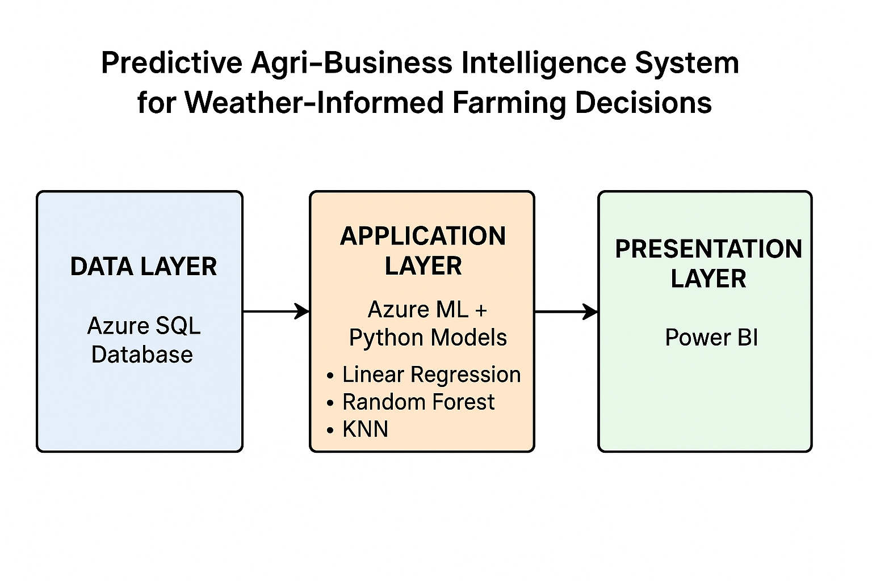
Figure 5: A labelled diagram illustrating the architecture

System Analysis

Use Case Diagram
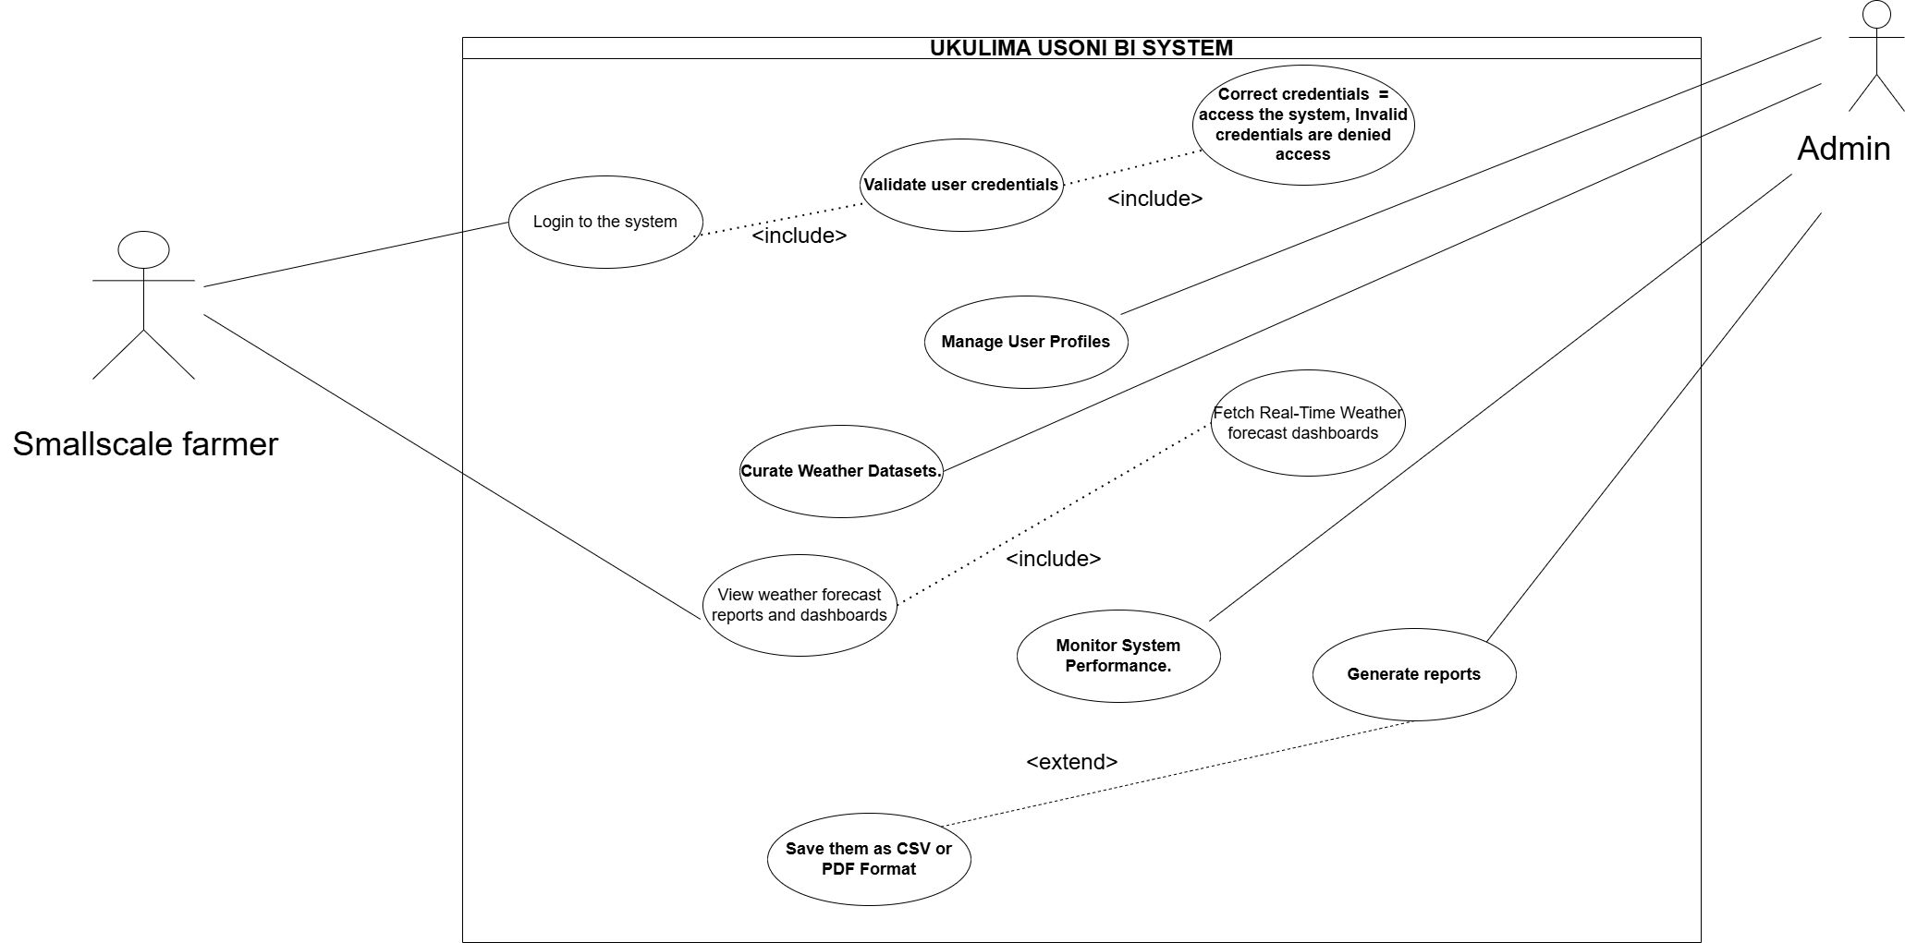
Figure 6: Use Case Diagram

System Designs

Class Diagram
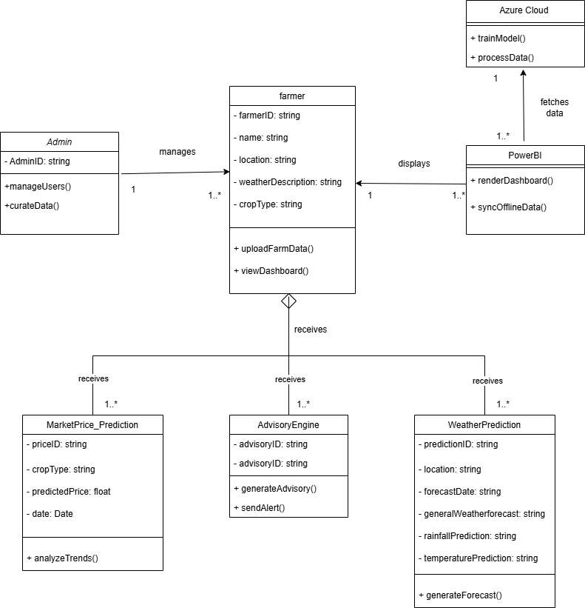
Figure 7: Class Diagram

Sequence Diagram
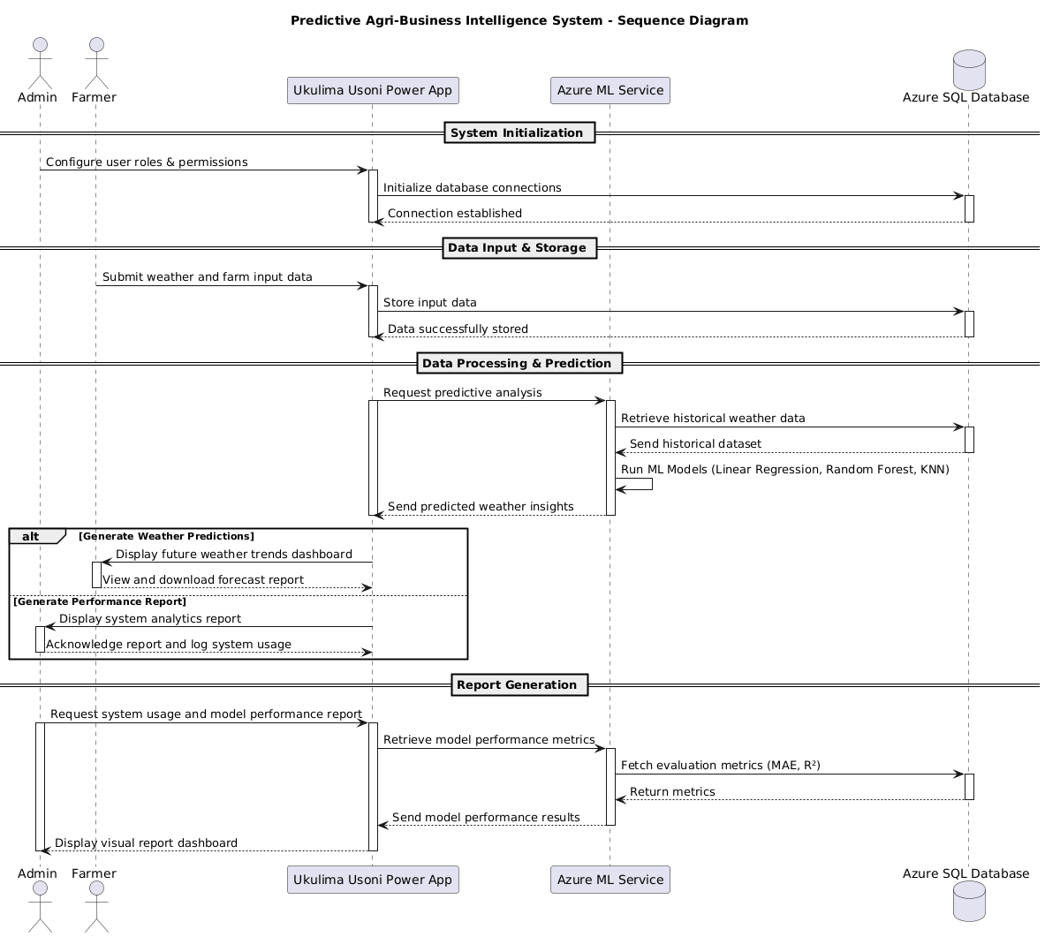
Figure 8: Sequence Diagram

Database Schema
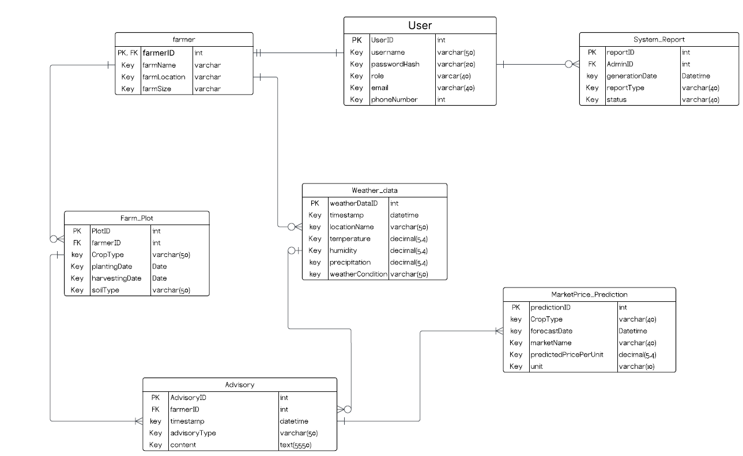
Figure 9: Database Schema

Chapter 5: System Implementation and Testing

Introduction
This chapter presents the implementation and testing phases of the Predictive Agri-Business Intelligence System. The implementation phase involved developing the system’s components, including the data ingestion pipeline, machine learning models, and visualization dashboards. Power BI and Microsoft Azure served as the primary platforms for integrating analytics, cloud storage, and visualization. Testing was carried out to ensure that the system met the functional and non-functional requirements outlined in Chapter 4. Both automated and manual testing approaches were applied to validate prediction accuracy, user interface performance, and data synchronization between Azure ML and Power BI.

Implementation

Wireframes
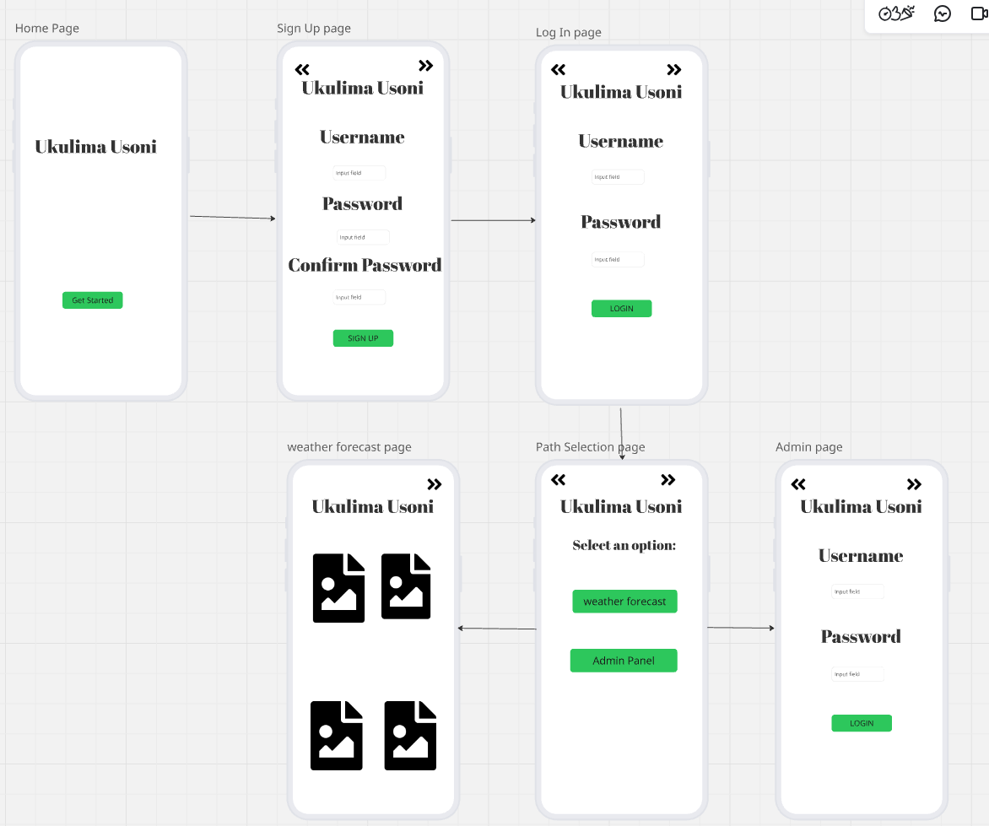
Figure 10: Wireframes

Installation Procedures
The system setup involved three major components, as explicitly expounded on in section 4.4:

Database Layer (Azure SQL Database)
This serves as the foundation for the system's successful operation. In this system’s sphere, a new Azure SQL Database instance was created in the Azure Portal. Then, after a suitable dataset was located that is in line with the weather features needed for the prediction tasks later on, it was then loaded onto the previously created Azure SQL Database instance. The dataset is then imported into the Azure Data Studio, then the creation of data pipelines to automate data ingestion and incorporate ETL(Extract-Transform-Load) procedures.
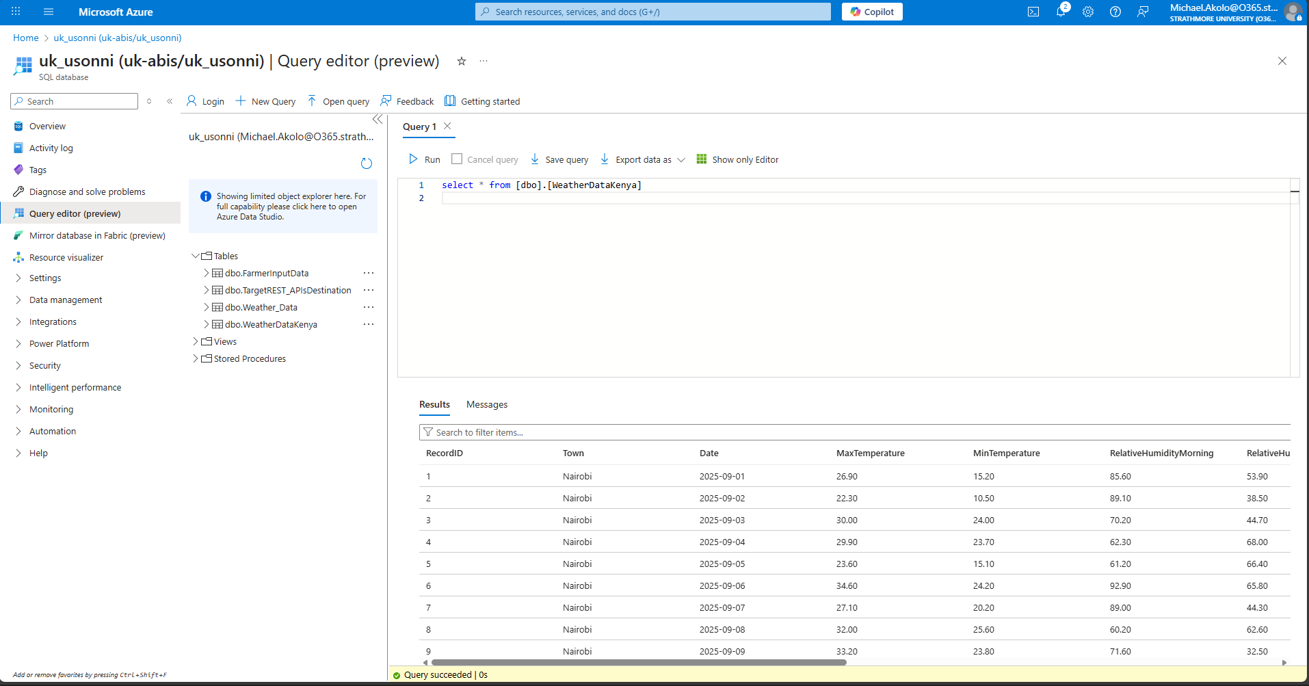
Figure 11: The ingestion of data into Azure SQL Database
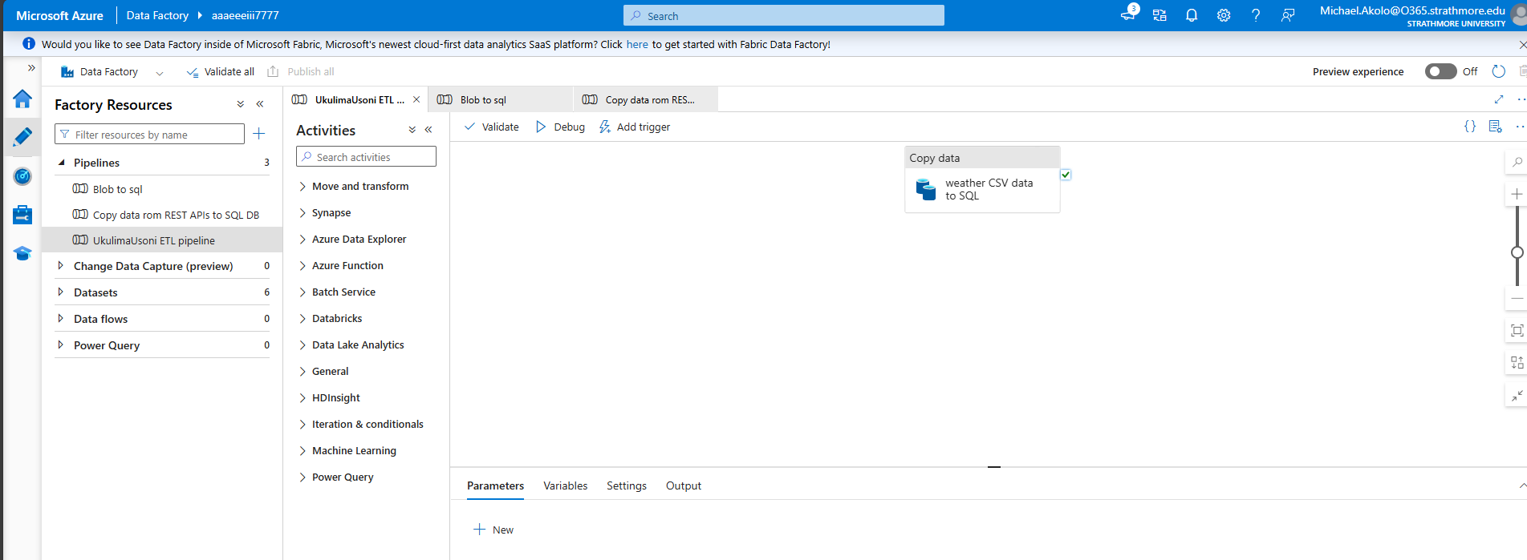
Figure 12: Data pipelines to automate the data ingestion process.

Application Layer (Azure Machine Learning + Python)
In this component, coding was gradually introduced and becomes a key instrument in setting up the BI system. For this system, Python 3.13 was installed, along with other necessary Python libraries such as Pandas, NumPy, Scikit-Learn, Matplotlib, joblib, and TensorFlow, to predict weather features effectively. The most important task in this segment was the training of predictive models (Linear Regression, Random Forest, and KNN) in the Azure ML Studio. Once the models are trained, the model with the least MAE (Mean Absolute Error) and the highest R-squared is selected to be used in the prediction task. The predicted data points are then stored as a CSV file and exported to Power BI for visualization.
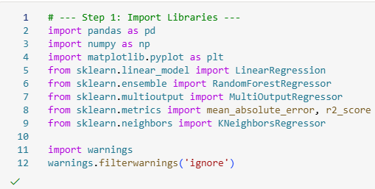
Figure 13: Importing necessary libraries
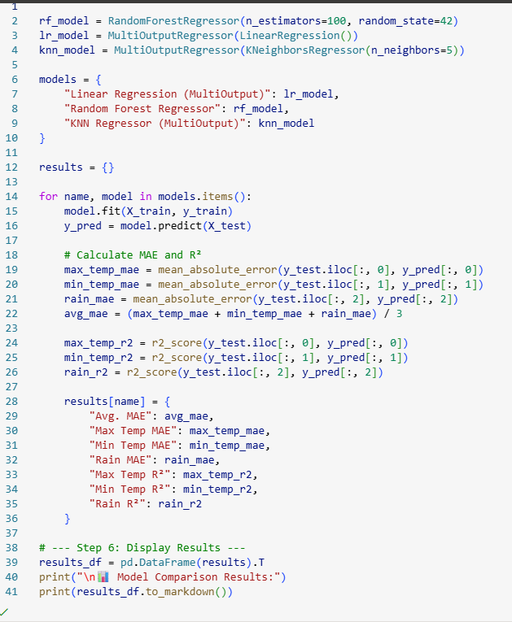
Figure 14: Training the models and selecting the most appropriate one based on the MAE and R-squared metrics calculated.
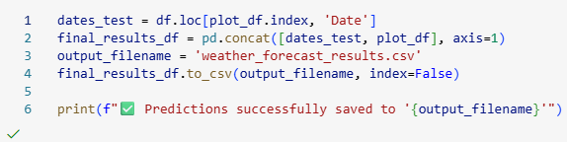
Figure 15: Saving the predicted data as a CSV file

Presentation Layer (Power BI)
In this part, the prediction CSV file is imported into the Power BI platform for visualization. Then, a dashboard containing numerous visuals highlighting insights in the predictions is made and then published into the Power BI Service, for easy access via the Ukulima Usoni mobile app.
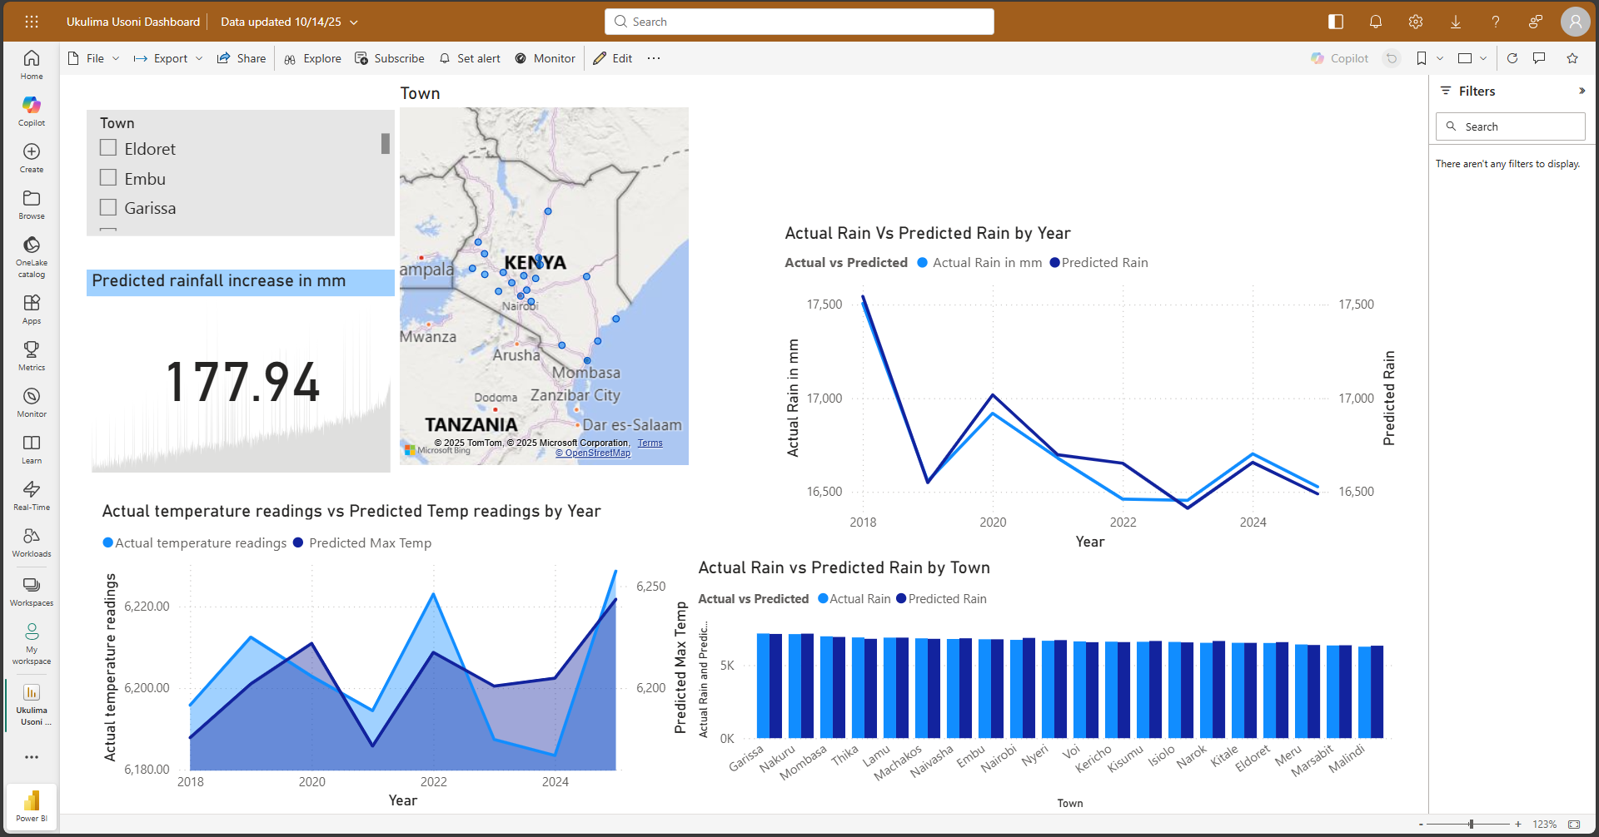
Figure 16: A Power BI dashboard containing visuals representing the predicted data.

System Manual
The table below encompasses the various models present in the system and their functionalities:
Table 5: A table describing the various models and their functionalities.
Module | Description
Data Management | Handles data cleaning, aggregation, and synchronization between Azure SQL and Power BI.
Prediction | Executes weather and market price forecasting using trained ML models.
User Management | Provides authentication and access control for farmers and the administrator.
Visualization
  Displays Power BI dashboards (weather forecasts).
Reporting | Exports reports in CSV or PDF formats for offline use.

Access Levels and Login Credentials
Verification of the access privileges that are attributed to each user level is demonstrated below using screenshots of each user level accessing the Ukulima Usoni app.
Table 6: A table detailing the access privileges along with the login credentials involved.
Role | Access Privileges | Username | Password
Farmer | View forecasts | Akollo | Akollo_Akollo_&5656
Administrator | Manage datasets, oversee model performance, and update dashboards. | Admin | Apollo&4455

Farmer Access
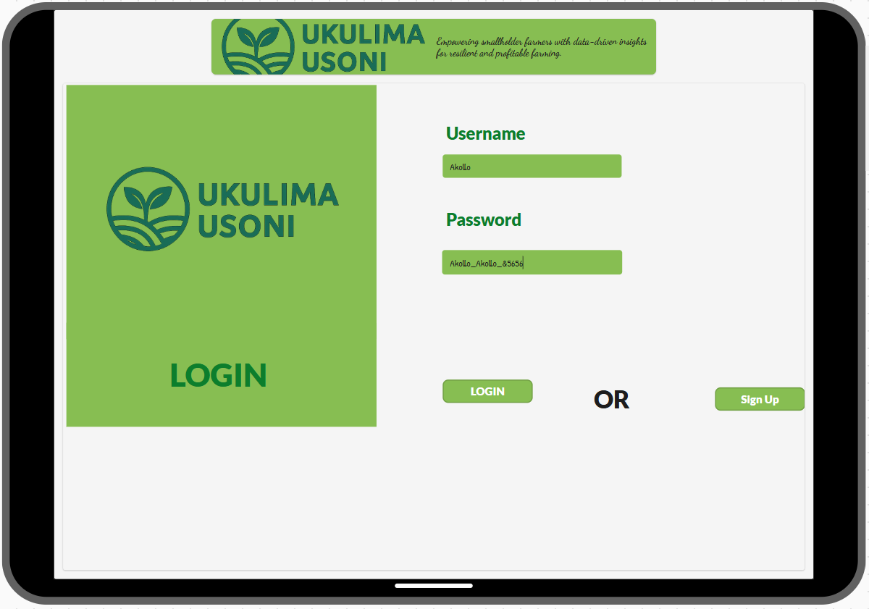
Figure 17: A farmer inserting his/her credentials
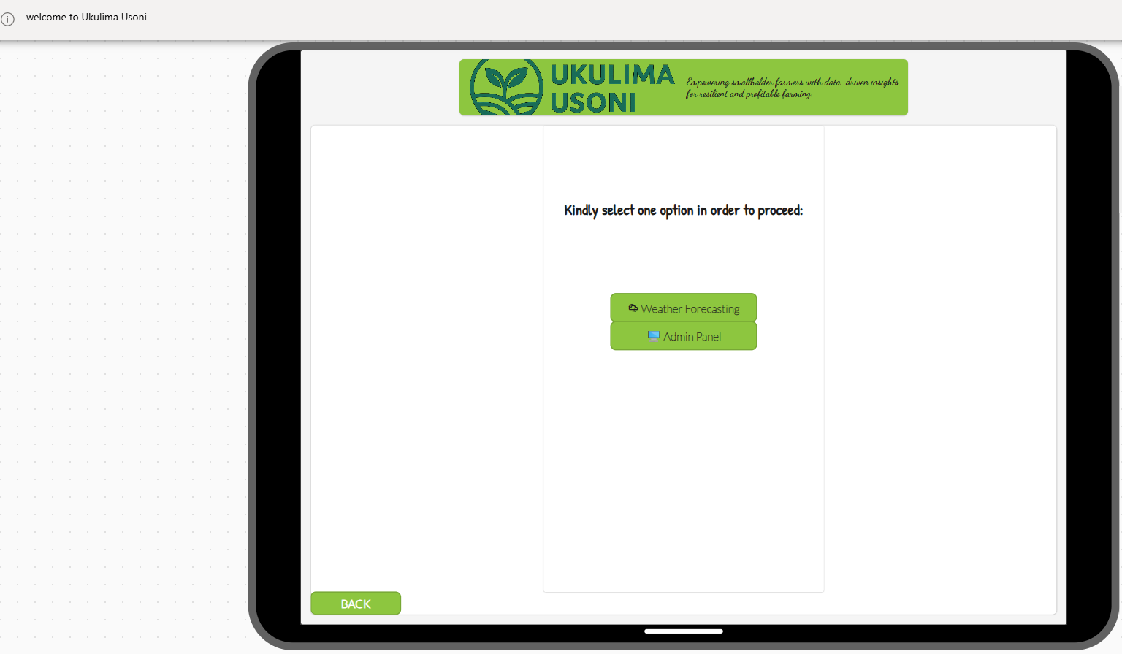
Figure 18; A farmer logging in the app successfully

Administrator Access

Figure 19: An administrator logging in to the app

Figure 20: An admin accessing the system

Report Generation
In the system, the only report that can be accessed and downloaded is by running a code in collab that produces a csv, excel or pdf report. The report offers comprehensive summary details as to how the models performed, the metrics they recorded and the model that as eventually chosen for the predicting and eventual deployment. The report that as generated is the weather forecasting model performance report.
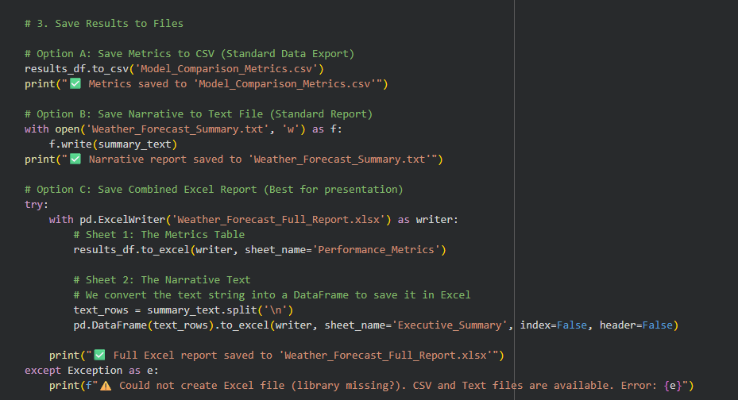
Figure 21: Code snippet for downloading the model summary performance report.
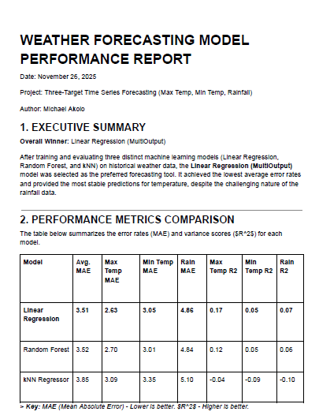
Figure 22: A front page view of the generated model summary performance report in a pdf format.

Testing

Testing Environment
Testing was performed to ensure consistent performance and real-time data accessibility using Azure services. Functional testing validated that system components—data preprocessing, model training, and dashboard updates—worked seamlessly. Performance testing focused on response time and model accuracy, while usability testing evaluated dashboard accessibility for end users. The tables below explicitly show the hardware and software specifications:

Hardware Specifications
Table 7: A table describing the hardware specifications.
Specification | Description
Processor | Intel(R) Core (TM) i5-1135G7 CPU @ 2.40GHz, 4 Cores
RAM
  8 GB
Machine Type | HP Pavilion Laptop
Storage | 512 GB SSD
Graphics | Intel Iris Xe Integrated GPU

Software Specifications
Table 8: A table describing the software specifications.
Specification | Description
Operating System
  Windows 11 (64-bit)
Development IDE | Jupyter Notebook, Visual Studio Code
Programming Language | Python 3.10
Machine Learning Framework | Scikit-learn, TensorFlow
Database System | Azure SQL Database
Cloud Platform
  Microsoft Azure (Machine Learning Studio, Blob Storage, SQL)
Version Control | GitHub
App development | Microsoft Power Apps

Test Cases
Table 9: A table highlighting the test cases done to verify the functioning of the system.
Test ID | Related Requirement | Check | Pre-condition | Test Data | Priority Level
T01 | FRQ1 |  | Historical weather dataset available. | weather_data.csv | High
  Verify that the system correctly loads cleaned weather data from Azure SQL Database.
T02 | FRQ2 | Check if ML models (Linear Regression, Random Forest, KNN) are trained without errors. | Cleaned dataset uploaded. | 5000 weather records | High
T03 |  | Confirm whether forecasted results (temperature & rainfall) are generated and stored in Azure SQL. | Models trained successfully. | Date range: next 30 days | High
  FRQ3
T04 | FRQ4 | Verify Power BI integration with Azure SQL for automatic dashboard updates. | Connection credentials configured. | Dataset: predictions_df | High
T05 | FRQ5 | Ensure users (Admin and Farmer) can log in and view respective dashboards. | Valid login credentials. | Username: Akollo  Password: Akollo_Akollo_&5656 | High
T06 | FRQ6 | Validate accuracy of model predictions compared to real-time weather data. | Historical + forecast data available. | MSE threshold < 5.0 | High
T07 | FRQ7 | Confirm that reports can be exported from Power Apps into PDF or CSV formats. | Admin logged in. | Click “Export” button | Low

Test Results
Table 10: A table displaying the resuslts of the tests taken earlier on.
Test ID | Expected Result | Actual Result | Status | Remark
T01 | System loads the dataset successfully and displays records in Power BI. | Dataset loaded correctly. | Success | Data integrity maintained.
T02 | Models train and output MAE and R² values without errors. | All models executed successfully. | Success | Optimal training performance.
T03 | Forecast data stored in Azure SQL for all target towns. | Predictions stored successfully. | Success | Data pipeline validated.
T04 | Dashboards auto-refresh when database updates. | Dashboards refreshed as expected. | Success | Smooth data integration.
T05 | Users access personalized dashboard upon login. | Access levels worked correctly. | Success | Authentication validated.
T06 | MAE < 5.0 for temperature and rainfall predictions. |  | Success
  rainfall predictions.
  Achieved average MAE = 3.5.
  Acceptable accuracy level.
T07 |  | Export completed successfully. | Success | Usability confirmed.
  Power Apps exports reports accurately to selected formats.

Chapter 6: Conclusions, Recommendations, and Future Works

Conclusions
The development of the Predictive Agri-Business Intelligence System successfully demonstrated how data analytics, machine learning, and cloud technologies can be integrated to address key challenges faced by small-scale farmers in Kenya. By combining real-time weather data and predictive modelling, the system provides farmers with actionable insights that support informed decision-making on planting and harvesting. Overall, the system contributes toward enhancing agricultural productivity, improving farm income stability, and supporting sustainable agricultural decision-making.

Recommendations
Based on the implementation and testing of the system, the following recommendations are made:
- Increase the volume and quality of data collected: More granular weather and price data, such as hourly readings, will significantly improve model accuracy.
- Farmer Training and Onboarding: Training programs should be conducted to ensure small-scale farmers understand how to interpret forecast dashboards and apply recommendations in real-world settings.
- Continuous Model Retraining: Machine learning models should be retrained periodically to account for changing climatic patterns, new crop varieties, and evolving market dynamics.
- Integration with Government and Agritech Platforms: Linking the system with county agricultural offices, the Kenya Meteorological Department, NCPB, and digital lending tools would enhance system reliability and impact.
- Mobile-First Optimization: Since many farmers rely on smartphones, the system’s Power App interface should undergo further optimization for offline use, reduced bandwidth consumption, and simplified navigation.

Suggestions for Future Work
Although the system provides strong predictive capabilities, several enhancements can be implemented in future releases, such as making the system more adaptable and agile to weather changes and catering to increased clientele:
- Advanced Machine Learning Techniques: Incorporate deep learning models such as LSTM and GRU for more accurate long-term forecasts. Moreover, expand predictions to include soil moisture, fertilizer recommendations, and pest/disease alerts.
- Automated Notification System: Integrate SMS and WhatsApp alerts to notify farmers of extreme weather events, market price drops, or recommended planting windows.
- GIS-Based Farm Mapping: Use satellite imagery and geospatial analytics to generate location-specific insights at the farm level rather than the town level.
- Financial and Credit Integration: Partner with microfinance institutions to offer credit scoring models based on predicted yield and market outlook.
- Community Feedback Loop: Add features allowing farmers to submit feedback, crop performance data, and local weather anomalies to improve model reliability.
- Full Integration with IoT Sensors: Incorporate soil sensors, rainfall gauges, and temperature detectors to create a real-time smart farming ecosystem.

Summary
This chapter concludes that the Predictive Agri-Business Intelligence System is a practical, impactful tool that empowers farmers with data insights previously unavailable to them. With strategic improvements and scaling, the system has the potential to transform small-scale agriculture in Kenya and contribute to national food security efforts.

References
Adede, A. M. (2022). Machine learning models for climate-smart agriculture: A review of practices in Sub-Saharan Africa. Journal of Agricultural Informatics, 13(1), 45–60.
Adede, A. O. (2022). Machine learning applications in Kenya’s agri-sector: Challenges and opportunities. . Journal of Applied AI Research, 4(2), 45–58.
Aker, J. C. (2011). Dial "A" for agriculture: A review of information and communication technologies for agricultural extension in developing countries. . Agricultural Economics , 42(6), 631–647.
Albrecht, C. B. ( 2020). Pairs (Re) loaded: system design & benchmarking for scalable geospatial application. IEEE Latin American GRSS & ISPRS Remote Sensing Conference (LAGIRS) (pp. pp. 488-493). IEEE.
Alila, P. O. (2006). Agricultural policy in Kenya: Issues and processes. Nairobi: Institute of Development Studies.
Alreshidi, E. ( 2019). underpinned by internet of things (IoT) and artificial intelligence (AI). Smart sustainable agriculture (SSA) solution, arXiv preprint arXiv:1906.03106.
Autio, A. J. ( 2021). Constraints for adopting climate-smart agricultural practices among smallholder farmers in Southeast Kenya. Agricultural Systems, 194, 103284.
Barga, R. V.-C. (2015). Predictive analytics with Microsoft Azure machine learning. pp. 221-241. Berkely, CA: Apress.
Becker, L. T. ( 2019). Microsoft power BI: extending excel to manipulate, analyze, and visualize diverse data. 45(3), 184-188.Serials Review .
Chen, T. &. (2016). XGBoost: A scalable tree boosting system. . In Proceedings of the 22nd ACM SIGKDD International Conference on Knowledge Discovery and Data Mining , pp. 785–794.
Chibuye, M. a. (2023). Current Trends and Gaps in Machine-Based Predictive Analysis in Agriculture for Better Agricultural Output Management–A Systematic Review. Zambia ICT Journal, 7(1).
Chung, L. N. (2012). Non-functional requirements in software engineering (Vol. 5). Springer Science & Business Media.
Climate change and food security: Risks and responses. FAO. (2016). Retrieved from Food and Agriculture Organization of the United Nations: https://www.fao.org/3/i5188e/i5188e.pdf
Collins, S. (2018). aWhere’s agronomic and weather based tips for smallholder farmers. e-Agriculture Promising Practice.
Dayıoğlu, M. A. (2021). Digital transformation for sustainable future-agriculture 4.0: A review. Journal of Agricultural Sciences, 27(4), 373-399.
Department, K. M. (2021). Annual weather and climate report: Kenya. . Nairobi: Ministry of Environment and Forestry.
Ekine-Dzivenu, C. C. (2022). Genomic analysis of milk yield and heat tolerance in small holder dairy system of sub-Saharan Africa. In Proceedings of 12th World Congress on Genetics Applied to Livestock Production (WCGALP) Technical and species orientated innovations in animal breeding, and contribution of genetics to solving societal challenges (pp. pp. 1709-1712). Wageningen Academic Publishers.
Emongor, R. A. (2014). Food price crisis and food insecurity in Kenya. Kenya Agricultural Research Institute.
Gandhi, R. V. ( 2007). In December 2007, International conference on information and communication technologies and development. Digital green: Participatory video for agricultural extension., pp. 1-10, .IEEE.
Herrero, M. R. (2010). Climate variability and climate change and their impacts on Kenya’s agricultural sector.
ICPAC. (2021). Climate outlook for the Greater Horn of Africa. . IGAD Climate Prediction and Applications Centre.
Ilieva, S. P. ( 2004). Analyses of an agile methodology implementation. Analyses of an agile methodology implementation. In Proceedings. 30th Euromicro Conference, 2004., (pp. 326-333). IEEE.
Intergovernmental Panel on Climate Change (IPCC). ( 2022)). Climate Change 2022: Impacts, Adaptation and Vulnerability. Contribution of Working Group II to the Sixth Assessment.
Kanda, E. K. (2022). "The status and challenges of a modern irrigation system in Kenya: A systematic review.". Irrigation and Drainage , 71 : 27-38.
Klein, J. &. (2013, June). A systematic review of system-of-systems architecture research. In Proceedings of the 9th international ACM Sigsoft conference on Quality of software architectures, pp. 13-22.
Kogo, B. K. (2021). a review of impacts on agriculture and food security. Environment, Development and Sustainability. Climate change and variability in Kenya, 23(1), 23-43.
Kogo, B. K. (2021). Environment, Development and Sustainability . Climate change and variability in Kenya: a review of impacts on agriculture and food security., 23(1), 23-43.
Lowe, D. (2003). Requirements Engineering. Web system requirements: an overview, 8(2), 102-113.
Lu, S. a. (2021). IBM PAIRS: Scalable big geospatial-temporal data and analytics as-a-service. In Handbook of Big Geospatial Data, pp. 3-34.
Malan, R. &. (2001). Functional requirements and use cases. Bredemeyer Consulting, 335-1653.
Mutua, J. M. (2021). Climate variability and its implications for agriculture in Kenya. . African Journal of Agricultural Research, 16(5), 650–660.
Ndungu, M. &. (2021). Review of digital agriculture solutions in East Africa. . Journal of ICT for Development, 3(2), 45–61.
Nzomoi, N. J. (2008). Agricultural commodity price fluctuation, poverty and food insecurity in Kenya.
Rafael, B. M. (2023). "The importance of agricultural development projects: A focus on sustenance and employment creation in Kenya, Malawi, Namibia, Rwanda, and Uganda." . Journal of Agricultural Chemistry and Environment , 12, no. 2 : 152-170.
Roberts, T. L. (2002). Factors that impact implementing a system development methodology. IEEE Transactions on software Engineering , 24(8), 640-649.
Srivastava, A. B. ( 2017, May). SCRUM model for agile methodology. In 2017 International Conference on Computing, Communication and Automation (ICCCA) (pp. (pp. 864-869)). IEEE.
Waswa, P. F. (2006). Opportunities and challenges for sustainable agricultural land management in Kenya. Environment and sustainable development: A guide for higher education in Kenya, 1.

APPENDIX A: TIME SCHEDULE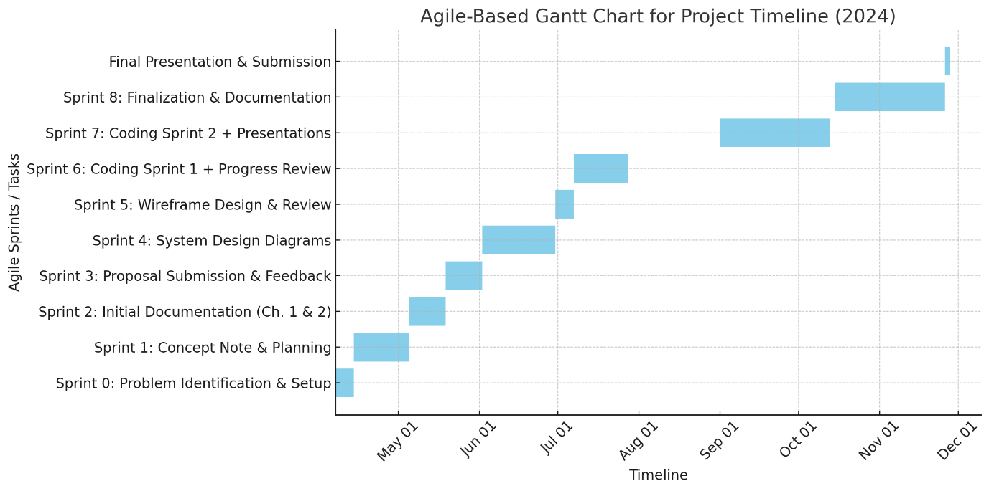

APPENDIX B: PLAGIARISM REPORT

